

Widgets

INSTALLATION GUIDE
for Openpay Widgets Extension for Magento 1

Step 1 :
Go to your projects root folder & then upload files and folder to the root.

If you have any custom theme then upload theme files to the current theme (app/design/frontend/<Your package>/<Your Theme>).

Step 2 :
Then login to magento admin panel: SYSTEM -> Configuration -> OPENPAY WIDGET -> Widget Setup

1. Enable the module :

Expand 'Openpay Widgets Configuration' & set 'Yes' value against 'Enable Widgets' field.

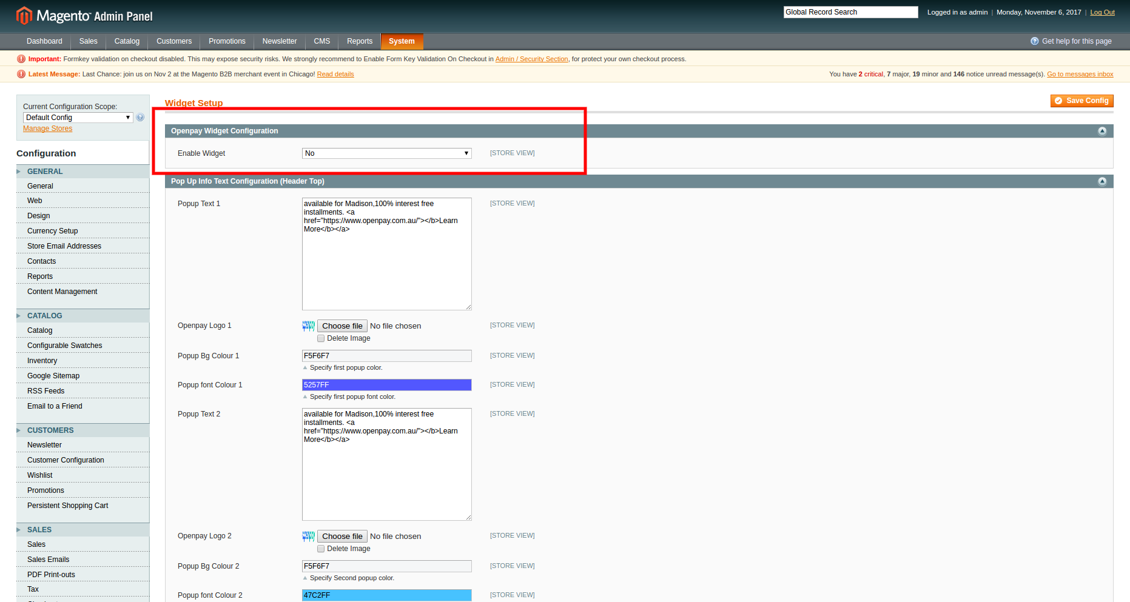

Click on 'Save Config'.

2. Set up 'Pop up info' widget :

Expand 'Pop Up Info Text Configuration (Header Top)' & fill out the fields as required.

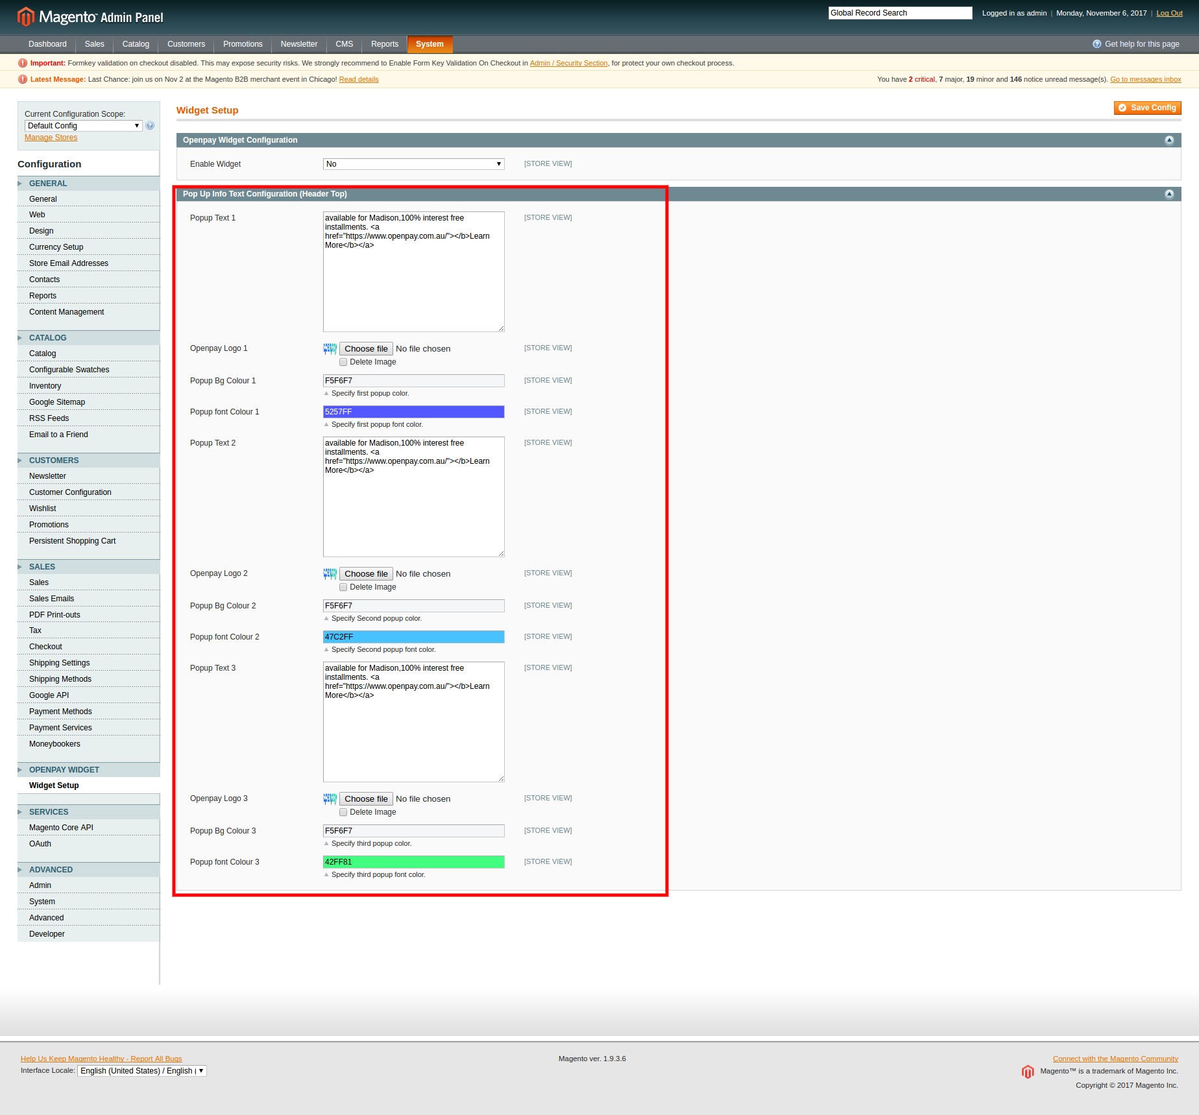

Click on 'Save Config'.

3. Set up 'Price calculator' widget :

Expand 'Price Calculator Widget' & fill out the fields as required.

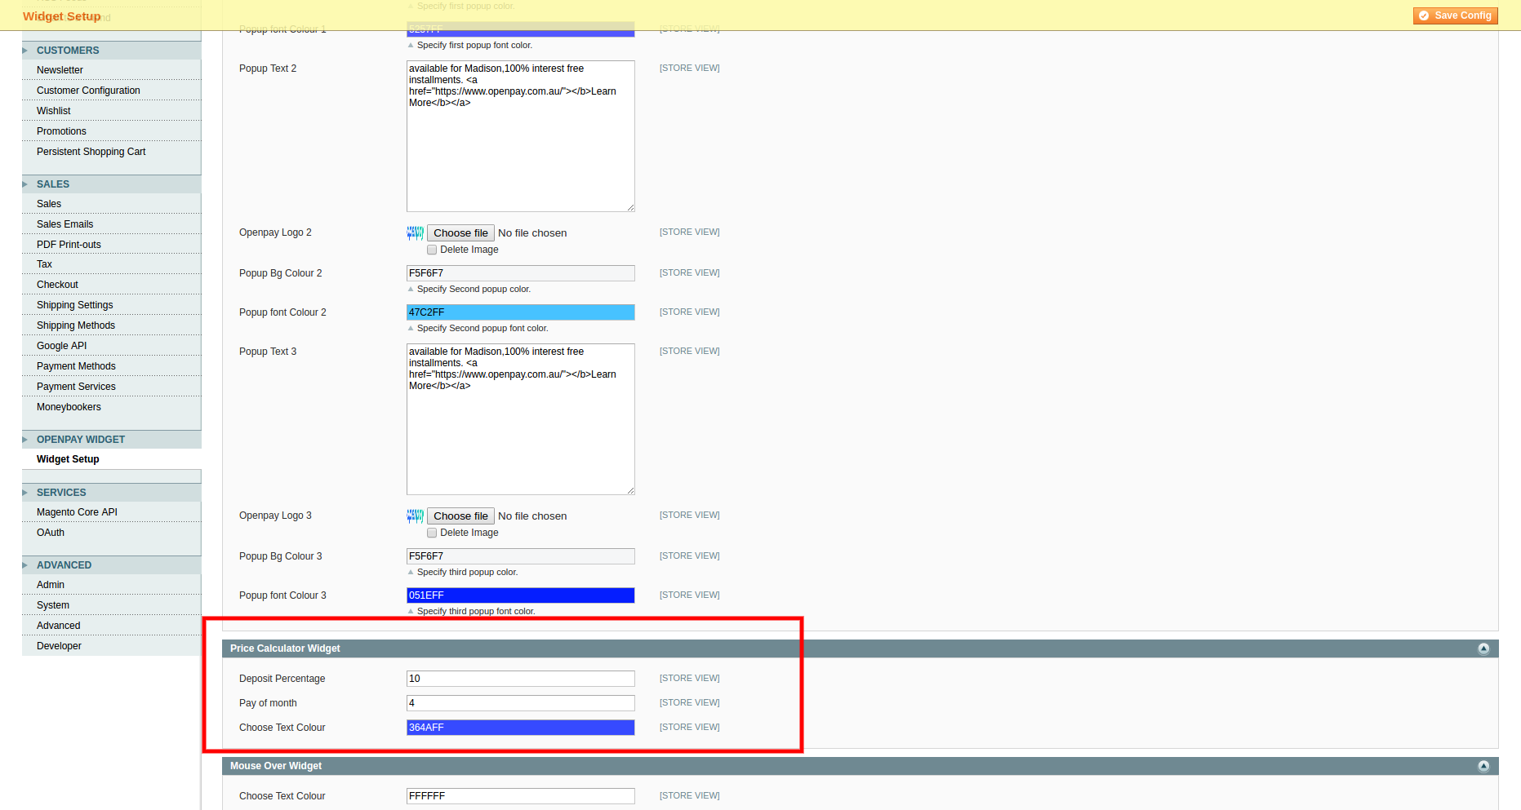

Click on 'Save Config'.

Frontend View :

'Pop up info' widget :

To enable the widget in frontend add the following code in <Your package>/<YOUR THEME>/template/page/html/header.phtml file of current theme.

<?php echo $this->getChildHtml('popup_widget') ?>

Add it before '<header id="header" class="page-header">'.



'Price Calculator' widget in Product List :

To enable price calculator widget in frontend add the following code in <Your package>/<YOUR THEME>/template/catalog/product/list.phtml file of current theme.

<!-- Openpay Price Calculator -->
<?php
$openpayPriceCalculatorHelper = $this->helper('addwidget');
echo $openpayPriceCalculatorHelper->getOpenpayPriceCallculationHtml($_product); ?>
<!-- End of openpay Price calculator -->

Add it after <?php echo $this->getPriceHtml($_product, true) ?> to show the widget after product price.

